Stock Project: Case Walmart (WMT)
Name
Institution
Course Number and Name
Instructor
Date
Table of Contents
Introduction 3
The History of Walmart 3
Most Current Annual Financial Statements 4
Income Statement 4
Balance Sheet 7
The Auditor’s Opinion 7
Charts Of the Stock’s Prices 8
Research and Analysis 8
Financial Ratios 8
Analysis 9
Positive/Innovative Information 9
Negative Side 11
Personal Opinion 11
References 13

Introduction
Walmart is an American multinational of department stores; Walmart occupies a significant space among the world's largest companies. Founded in the 1960s by Sam Walton, the chain is the largest of its kind in the American market, earning an average of US$177 billion a year. In addition, Walmart has more than 4.9 thousand branches in East and West countries. Walmart is one of the most successful companies in the world today. Walmart is an American multinational retail company that operates supermarkets, department stores, and grocery stores. To reach that point, Walmart has had a long journey with various achievements and obstacles in it.

The History of Walmart
The Walmart embryo has been around since 1950 when its founder, Sam Walton, opened his first store in Bentonville, Arkansas, USA, under the name Walton's 5-10. Bentonville was chosen because his wife, Helen Robson, wanted to live in a small town. In addition, Walton reasoned to avoid direct competition with other retail giants such as Sears and Kmart (Walmart, 2021). Because most well-known retailers gather and compete in big cities. On July 2, 1962, Walton opened his first Walmart in Rogers, Arkansas. Walmart's "sell brand merchandise at low prices" approach to retail soon became the driving model for all other retail stores. This step was a success.
Walton had 24 branch stores in 1967, with 12.7 million US dollars in sales revenues as it grew. Walmart expanded its market by opening stores in Sikeston, Missouri, and Claremore, Oklahoma, in 1968, and Delaware, Kansas (Walmart, 2021). Walmart became a public company in 1970 and was listed on the New York Stock Exchange two years later, in 1972. Walmart's first stock sold for $16.5 per share.
By the time Walmart expanded into Texas in 1975, it had more than 125 operating stores with 7,500 employees (partners) and total sales of $340.3 million (Walton, n.d). In 1998, Walmart launched the Wal-Mart Television Network, an in-store television channel announcing discounts, products, news, and entertainment from the entertainment industry. By 2007, shoppers were able to order any item online and pick it up at the store. To date, Walmart provides two-day free shipping for more than two million items. Currently, Walmart is one of the biggest chain stores globally.

Most Current Annual Financial Statements

Income Statement
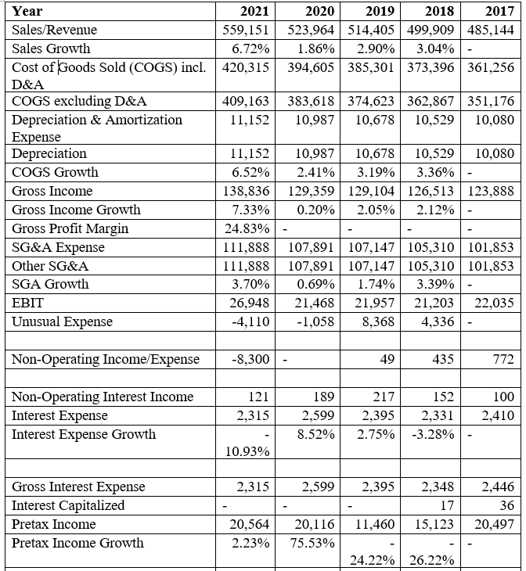
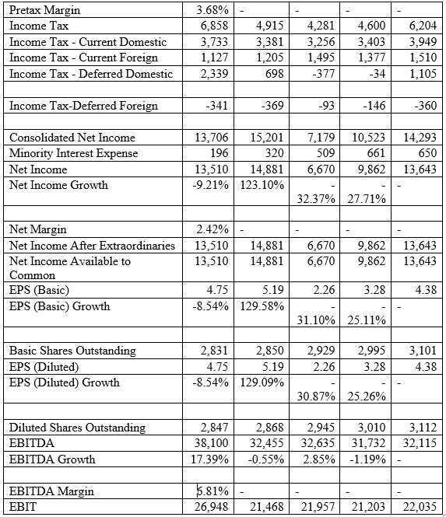

Balance Sheet
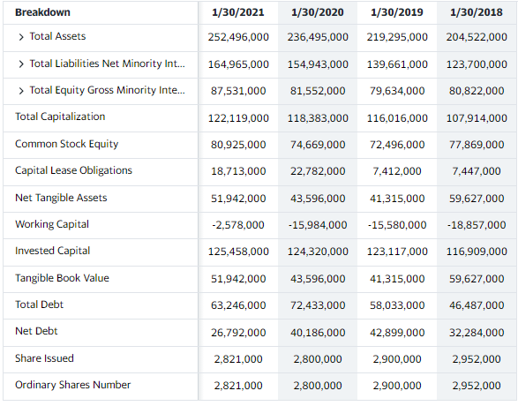
Figure 1: Balance sheet source: Yahoo finance
Generally, the company has been performing well financially since its total assets have increased from 236,495,000 to 252,496,000. The assets shown in the balance sheet indicate all the cash, land, inventory, and stock owned by the company. An increase in the balance sheet total thus means the financial health of the company is good. Besides, the company's revenue has been increasing gradually for the past four years, and thus the company can be said to be doing well.

The Auditor’s Opinion
According to the auditor report, the company and its subsidiaries have presented its financial statements and reports, reflecting the company's true financial standing. The company has in the past and complies with the accounting stands and well-required laws in their area of operations. However, from the financial report, the company has a considerable debt burden that should be fulfilled, but with the review of its financial state, it can offset the debt without overstretching. Walmart is in fair standing dealing with the Auditor's review. The company is very large, so it is hard to ever be in good standing dealing with many different financial aspects. The report from the Auditor confirms the strength and resilience of the company to continue performing well. Based on the financial report, investors can feel safe investing in the company and being part of the ongoing success.

Charts Of the Stock’s Prices
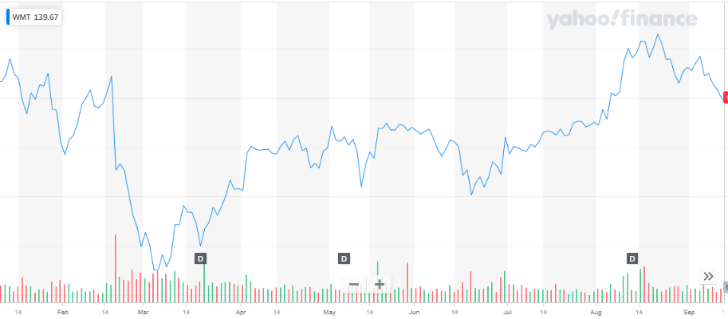
Figure 2: Recent Stock Prices (2021)
In the past eight months, the stock pricing for Walmart slightly increased, but around March 2021, the prices had fallen below and continued to increase since then.

Research and Analysis

Financial Ratios
Current Ratio: 0.81
P/E Ratio: 23.74
Earnings per share: 5.00
Current stock price per share: $118.69
The current ratio is a company's current assets divided by current liabilities. This ratio is used to determine if a company has enough liquidity to cover the current liability it owes. Walmart has a low current ratio, but it is a very large company, so that is why (Finance.yahoo.com, 2021). The P/E ratio indicates how high of a demand a company is in the stock market. Walmart is a little lower, but it is because it is already bought up in stocks, and they are high at the moment. Earnings or share indicates how much a company makes off each stock purchased. Walmart makes 5 dollars per share.

Analysis
Walmart is in good standing. The company's stock prices have constantly been increasing in the past five years I have seen from the stock market chart. In the past five years, the compiles have increased on revenue, stock pricing, assets, and stockholders. Liabilities have been maintained and have not increased by a large amount.
Walmart is a large grocery store and only has one real competitor, Target. I would consider Walmart the main market leader because no other company has as many locations and carries as many things as they do. Although Walmart is not known for the best quality of items or even best customer service, they still have the lowest prices compared to any other store nationwide. Walmart is innovative because the company is always coming up with ways to save customers more money and offer as many different items as possible.
Management in Walmart has not always been the greatest, but it can be a little difficult to keep every store to the Walmart standard with any large retail store of that magnitude. The company 10k sec report identified Walmart at fair standing, which is not bad considering all the bad rumors about Walmart in general.

Positive/Innovative Information
Walmart does not stop innovating. The company knows it needs innovations to fight Amazon, its archrivals. She has big innovation initiatives, just hired 2,000 more people to create new things, and worked with several startups to improve even more. For instance, Walmart has launched a new feature with unique maps for each store to complement its smartphone app. Through them, customers can know where each item is located, by aisle and shelf. The solution is part of a Store Assistant initiative, which aims to improve the consumer experience before leaving home and arriving at the store.
According to Mark Matthews, Vice President of Digital Acceleration, approximately 80 percent of consumers make paper shopping lists. With that in mind, the new listings feature in the Walmart app allows users to enter custom terms like popcorn or coffee maker and check the inventory of items at their local store (Heller, 2017). As the solution is integrated with maps, products can be located in their specific section.
Also, the company is integrating its customers' purchase data into the app so that all items purchased – whether in physical stores or online – can be easily accessed. Users can scan a paper receipt for future transactions or request a return from the app itself. To do this, simply select the item in the digital history, create a barcode on the mobile device, present it in one of the physical stores and leave the product (Heller, 2017). According to Matthews, this is the kind of omnichannel experience that will work for the brand's customers. The company is still studying integrating the feature with smart home appliances and creating a voice interaction.
Another secret revealed is charity, which Walton has never advertised before. Having lived in provincial towns and driving around them in his pickup, he knew their problems well. In parallel with the construction of the new store, its employees learned the addresses of local charitable foundations. After opening, each store established scholarships for local college students and occasionally held charity sales. In addition to educational institutions, money was donated to theaters, churches, libraries, zoos, firefighters, in general, all those institutions traditionally located on the city's central street. Walton did not ignore even the mayors of small towns (Ertem-Eray, 2020). He established the American Hometown Leadership Award. Naturally, in his memoirs, Walton did not ignore the recipes for prosperity traditional for this genre; in particular, he emphasized that owners of small stores can well coexist next to Walmart if they create their niche. For example, they will specialize in paints, which are available in limited quantities at Walmart.

Negative Side
Walmart supermarket has been known for practicing discrimination against black people. The company had a long-standing policy that required the stores to keep personal care products used by black people in locked windows. This act shows that the company sees less of black people and cannot trust them. However, this policy was recently abolished by the company, but there are still worries about the commitment of the company t fight racism and discrimination against black people in society. Besides, in the history of Walton, there is one, but a very large spot, which all his ill-wishers pay attention to (and he, like any rich person, always had many of them). The fonder is known to have ruined thousands of small Mom & Pop shops.

Personal Opinion
I think overall, Walmart is a good company. I think their core beliefs and values started by Sam Walton have come a long way and kept the company together because of them. I would like to work for Walmart rather than compete against them because I think the company can do a really good thing and do good things by helping its communities. Walmart offers the largest private employment offer in the world, with more than 2 million workers. I like Walmart's products because they are cheap conventional, and the store carries pretty much anything you need. I would recommend the store, but I like HEB more for produce. The company is well known for taking part in global CSR projects that have continued to impact the communities that occupy the area where they operate. Walmart's participation in CSR is one of the desirable characteristics that attract me to great cooperate success.
I would also invest in Walmart's stock for a number of reasons. First, Walmart has implemented strict spending discipline that has allowed its sales space and income to grow faster than its expenses. Credit Suisse analysts noted in a report that in the fourth quarter of 2020, cash expenses grew 3.7%. Sales area grew 3.9%, and consolidated revenues (including Central American operations) climbed 4.3%.
Also, in the fourth quarter of 2020, Walmart reported an operating cash flow (EBITDA) of 13,492 million, 13% higher than the expectations of the analyst consensus due to lower operating expenses as a percentage of sales (Tikhonova, 2021). On the other hand, the company's financial profitability (ROE) increased to 21% compared to 16% in 2013. Walmart's ROE exceeds that of other self-service companies that are also publicly traded, and that they range between 8% and 9%.

References
Ertem-Eray, T. (2020). Addressing corporate social responsibility in corporations: a content analysis of Amazon's and Walmart's websites. Corporate Communications: An International Journal.
Finance.yahoo.com. (2021). Yahoo is now a part of Verizon Media. Finance.yahoo.com. Retrieved September 17, 2021, from https://finance.yahoo.com/quote/WMT/financials?p=WMT.
Heller, F. K. (2017). Technological innovation applied to Walmart and Tesco's supply chain (Doctoral dissertation).
Tikhonova, M. (2021). Financial Analysis of Walmart and Costco in 2017-2018. SCIENTISTs, 100.
Walmart. (2021). Our History. Walmart. Retrieved September 17, 2021, from https://corporate.walmart.com/our-story/our-history.
Walton, S. History of Walmart.

